HOMEWORK 3 110611043 林揚森

1. Methods:

• Laplacian filter in spatial domain sharpening

1. Convolution Operation : The function conbolutinon_2d takes an image and a kernel as inputs.
2. Laplacian Kernel: The Laplacian kernel used is a simple 3x3 matrix [[0, 1, 0], [1, -4, 1], [0, 1, 0] ] to highlighting edges.
3. Applying filter to grayscale image.
4. Combining the original and filtered image.

• Laplacian filter in frequency domain

1. Fourier Transform: Convert the image from the spatial domain to the frequency domain using the Fourier Transform (np.fft.fft2).
2. Laplacian filter in the frequency Domain:
3. Construct a Laplacian filter to accentuate high-frequency components.
4. Normalize the filter to control its overall influence.
5. Blend the original Fourier-transformed image with the Laplacian-filtered version. Adjusting scaling factor alpha to adjust the sharpening effect.
6. Inverse FT using np.fft.ifft2
7. Results

• Laplacian filter in spatial domain sharpening

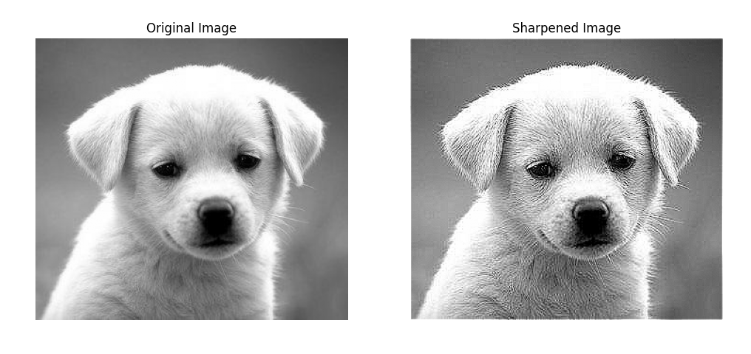

• Laplacian filter in frequency domain



1. Feedback

This Homework is a good practice for Learning the concept of Fourier Transform image sharpening. The chosen in filter and the parameter adjustment bothered me a lot. It’s kind of hard without find some online resources.